DIY Volunteer Role Description 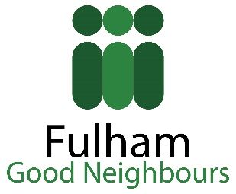

Summary of the role and the activities involved:

Role
You will assist older and disabled people with small repairs inside their properties. The role could involve:
- Taking down curtains
- Putting up a shelf
- Using a drill
- Putting furniture together from flat pack
- Changing light bulbs
- Changing a washer
to name a few
This could include:
Visiting an older person at an agreed date and time to complete the agreed DIY task.

Personal qualities most suited to this role
• A friendly and cheerful manner
• Patience
• Good listening skills
• Good time keeping skills
• Good problem solving skills
- DIY skills
- Health&Safety Awareness

Any other information
We will conduct a DBS and reference check.

How many hours you need to give, when and where:
You would normally volunteer as and when required depending on your availability and the errands you wish to take on. This could be as often as once a week or as rarely as once every few months.

What training will be necessary and available:
There is no formal training and you should accept only the errands you are able and confident to accomplish. You will be provided with a general induction to your volunteering role at Fulham Good Neighbours.

Who will supervise you:
Your supervisor would normally be:
Ruth George
Volunteer Co-ordinator
Fulham Good Neighbours
Rosaline Hall
70 Rosaline Road
London, SW6 7QT
Tel. 0207385 8850
Email: ruthgeorge@fulhamgoodneighbours.org
Web: www.fulhamgoodneighbours.org

What expenses are payable:
Your travel expenses will be provided.

